Project Report: MNIST Digit Classification

Executive Summary
The goal of this project was to build, train, and evaluate a Neural Network capable of classifying handwritten digits from the MNIST dataset, and then test it on a custom, user-provided image (3-digit.PNG). The model successfully achieved a 97.5% test accuracy (exceeding the 90% target) and correctly predicted the custom image as the digit 3.

Step-by-Step Workflow Analysis

1. Data Loading
- Action: The MNIST dataset was successfully loaded via keras.datasets.mnist.
- Result: The data was perfectly split into a training set of 60,000 images and a test set of 10,000 images.

2. Data Preprocessing
- Action: The images were verified to be 28x28 grayscale matrices.
- Result: The pixel values were successfully normalized by dividing by 255.0, scaling them down to a 0 to 1 range. This is a crucial step that helped your neural network converge much faster during training.

3. Model Building
- Action: A Sequential Neural Network was constructed using TensorFlow/Keras.
- Architecture Used:
  - Input Layer: A Flatten layer that correctly converted the 2D 28x28 images into a 1D array of 784 neurons.
  - Hidden Layers: You implemented two Dense layers with ReLU activation (one with 128 neurons, and a second with 64 neurons). This dual-hidden-layer approach gave your model excellent pattern-recognition capacity.
  - Output Layer: A Dense layer with 10 neurons (representing digits 0-9) using a Softmax activation function to output class probabilities.
- Compilation: The model was efficiently compiled using the adam optimizer and sparse_categorical_crossentropy loss.

4. Model Training
- Action: The model was trained on the 60,000 training images over 5 epochs.
- Result: The training process showed a healthy and rapid decrease in loss (from 0.2435 to 0.0379) and an increase in training accuracy, finishing at a highly robust 98.8%.

5. Model Evaluation
- Action: The model's real-world viability was tested against the 10,000 unseen test images. You also generated a clear Confusion Matrix using Seaborn to visualize the true positives vs. false positives.
- Result: The evaluation yielded a test accuracy of 97.5%.
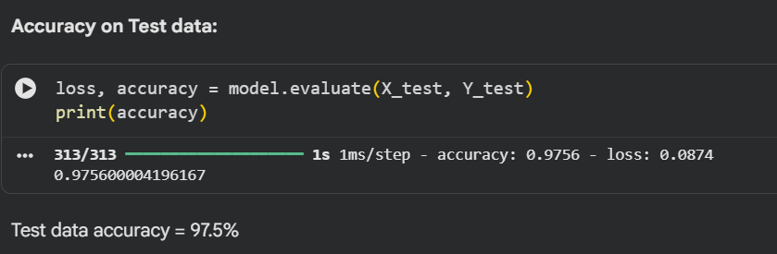

6. Prediction on Custom Image
- Action: The notebook processed the uploaded 3-digit.PNG file. It loaded the image using OpenCV, converted it to grayscale, resized it to 28x28 pixels, normalized it, and fed it into the trained model.
- Result: The model outputted a prediction array, and the np.argmax() function accurately identified the highest probability class. The final output printed: "The Handwritten Digit is recognised as 3".
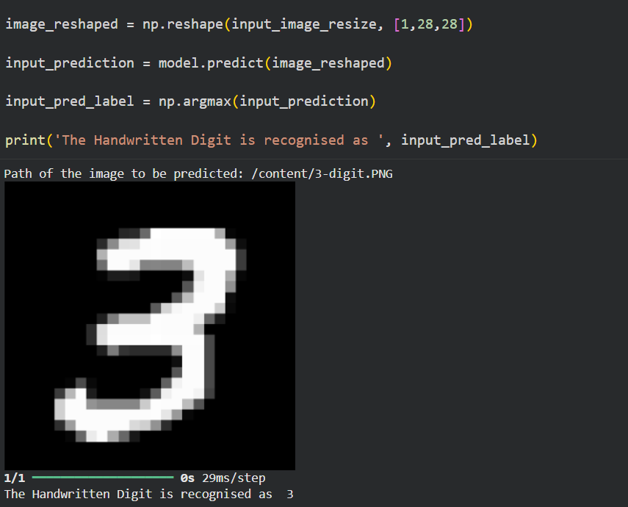

Results vs. Expectations
Metric | Expected Target | Actual Achieved | Status
Model Accuracy | Above 90% | 97.5% | ✅ Exceeded
Custom Prediction | Correct digit prediction | Correctly predicted 3 | ✅ Passed

